**Q2: How do you perform canary build?**

A canary build is a deployment strategy that involves releasing a new version of a software application to a small subset of users before rolling it out to the entire user base.

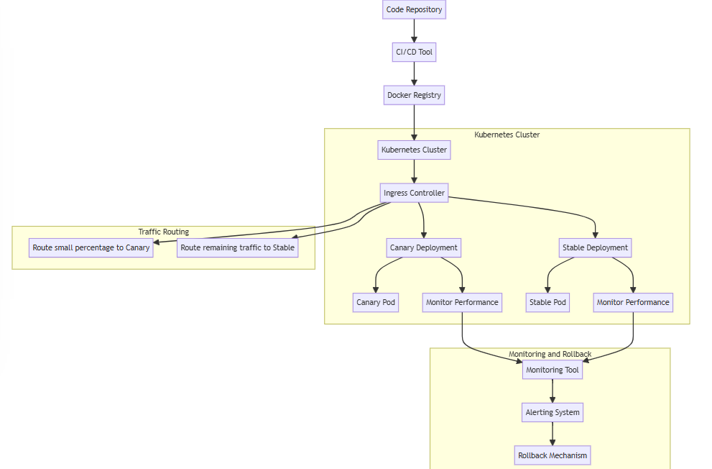

**Steps for Canary Building**

1. **Initial Setup:**
   * A initial CICD should be there in place pipeline which shall be capable of building, testing, and deploying our application automatically.
   * We will utilize git for version control and tracking
2. **CI/CD Pipeline Configuration:**
   * **Source Control Integration:** Configuring CI/CD tool (Jenkins, GitHub Actions, Azure Pipelines) to trigger a build whenever changes are pushed to the repository.
   * **Automated Testing:** Includes unit tests, integration tests, and other relevant tests to ensure that new code doesn't break existing functionality.
3. **Build and Package the Application:**
   * **Containerization:** Using Docker to containerize our application. Creating a Docker image for new version of the ML model.
4. **Deploy the New Version to a Subset of Users:**
   * **Kubernetes Deployment:** Using Kubernetes we will manage our deployments. Creating a deployment for new version and configuring it to only route traffic to a small subset of users.
   * **Service Configuration:** Creating a service that routes traffic to both the stable and canary versions, but only a small percentage to the canary version.

1. **Monitor the Canary Deployment:**
   * **Metrics and Logging:** Using monitoring tools like Prometheus, Grafana, and ELK stack to monitor the performance of the canary deployment. We can track increased error rates or latency.
   * **User Feedback:** Collecting feedback from users who are interacting with the canary version. This can be done through surveys or direct feedback channels.
2. **Analyze Results and Decide:**
   * **Success Criteria:**
   * We can define our success rates based on specific performance metrics, error rates, or user feedback thresholds.
   * **Decision Making:** If the canary deployment meets the success criteria, can proceed with rolling out the new version to the rest of the users. If issues are detected, rolling back the canary deployment and addressing the problems before trying again.
3. **Full Rollout:**
   * Once the canary deployment is deemed successful, we can update the deployment to route 100% of the traffic to the new version.